TOPIC ONE: KEEPING POULTRY
Poultry: Poultry refers to domestic birds
Poultry keeping: This is the rearing of domestic birds.
Terms used in poultry and their meanings
  - Hen– Adult female chicken.
  - Cock – Adult male chicken.
  - cockerel – Young male from 8 weeks on wards
  - capon – castrated male
  - pullet – young female
  - chick – very young bird from hatching to 8 weeks
  - Incubation – process by which an egg is given necessary condition to hatch into a chick
  - Incubator – A machine used to hatch eggs into chicks
  - Layer – Type of bird kept mainly for egg production
  - Broiler – This is a type of chicken kept mainly for meat production.
  - Brooding – It is the giving of special care to young chicks below 8 weeks.
  - Broody hen – A hen sitting or incubating eggs to hatch them.
  - Brooder – A special structure for keeping chicks below 8 weeks
  - Culling – This is the removing of unwanted chicken e.g. sick or un productive birds from the flock.
  - Moulting – The process by which birds shed their feathers to replace them
    - Importance of poultry keeping
- For meat production
- For egg production
- For cultural purposes like dowry, rituals
- Source of income when sold.
- Their droppings are used as manure.
- Some birds are kept as pets.
- Feathers can be used for decoration
NB: Their eggs and meat are sources of proteins to our bodies.
Types / Examples of poultry
  - chickens
  - ducks
  - Turkeys

  - Guinea fowl
  - Geese
  - pigeons
(f) External features of a domestic bird
Comb, beak, wattle, breast, nape, wing, toe, claws, spur, tail feathers, earlobe and eye.
Parts of a domestic bird
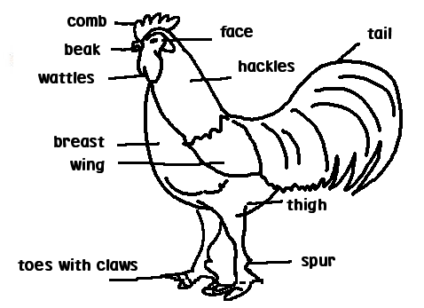
(g) Functions of each part
  - Beak – picks up food
  - Nostrils – They are sense organs for smell
  - Eyes – Enable birds to see
  - Wings – Enable birds to fly
  - Claws – for scratching the ground to look for food
  - Spur – For protection
- Firm grip during mating
Feathers
Feathers are the outermost covers of the bird’s body.
Uses of feathers to birds
  - Keep the bird warm.
  - Protect their body from mechanical injury
  - Enable birds to fly
  - Give shape and colour for easy identification
  - For attraction to opposite sex during mating period
Uses of feathers to people
- For decoration
- For making pillows
Types of feathers
- Quill feathers/flight feathers
- Body feathers/covert feathers
- Down feathers/ contour feathers
- Filoplume feathers/hair feather
a) Quill feathers/flight feathers
These are feathers that help a bird to fly.
Structure of Quill Feather
Barbs forming vanes
Shaft

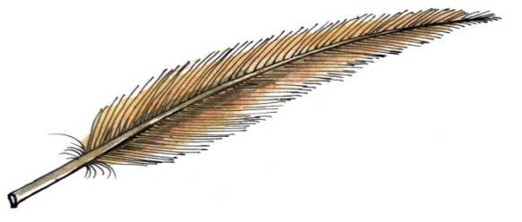
Quill
Vanes
After shaft
Meaning of each part
  - shaft – The long hard part in the middle of the feather
  - vane – Flat expanded part of the feather
  - Quill – The extreme end of the shaft
  - Barbs – They form the vane
b) Body feathersor covert feathers
  - These cover most of the bird’s body and keep the bird warm
Structure of body feather
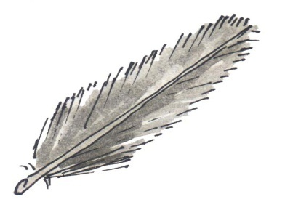
c) Thedown feather
These are the first feathers to appear on a chick
They help to prevent heat loss from the bird’s body
Structure of a down feather.
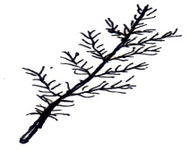
Filoplume (Hair feathers)
These are feathers found nearest to the skin of a bird
They can be clearly seen after removing the body and down feathers.
Structure of a filoplume feather
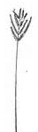

Differences between a hen and a cock
Cock Hen
- Has a big comb and wattle - Has a small comb and wattle
- It has a long spur - Has a short spur
-Has shiny nape -Has dull nape
-Has long tail feathers -Has short tail feathers
Types of chicken
  - A type of chicken is a class of chicken kept for specific purpose.
There are types of chicken.
  - Broilers
  - Layers
  - Dual purpose chicken
(a) Broilers (table birds)
These are a type of chicken kept mainly for meat production
Examples of broilers
- Ply mouth rock
- Light Sussex
(b) Layers (light breeds)
These are a type of chicken kept mainly for egg production
Examples of layers

- White leghorn
- Ancona
- Minorca
- Brown egger
- Sykes

(c) Dual purpose breeds
These are a type of chicken kept mainly for both meat and egg production
Example of dual purpose chicken

- Rhode Island Red
- New Hampshire
- kroilers
- Black australorp

Breeds of chicken
A breed of chicken is a family of chicken with similar characteristics
Breeds of chicken include:

- White leghorn
- Ancona
- Light Sussex
- Minorca
- Sykes
Types of breeds of poultry

- Local breeds
- Exotic breeds
- Cross breeds

- Local breeds
They are sometimes referred to as indigenous or native breeds
They are called native or local because they existed in Uganda for a very long time.
N.B These types of breeds are named after their area of origin e.g. enkonkoenganda
Characteristics local breeds
  - They are more resistant to diseases and parasites
  - They take a long period of time to grow
  - They lay small and few eggs during each laying season
  - They can feed on a variety of feeds.
  - They can withstand bad weather conditions.
  - They produce less chicken
  - They have different colours
Advantages of local breeds over exotic breeds
  - Local breeds are more resistant to disease than exotic breeds.
How to improve upon the local breeds of poultry
  - By carrying out cross breeding.
(b) Exotic breeds
  - These are breeds which were imported into Uganda from other countries e.g white leghorn, Rhode Island red and light Sussex etc
Characteristics of exotic breeds
  - They are less resistant to parasites and diseases
  - They grow and mature fast.
  - They laymanyeggs
  - They have the specific colour.
  - They produce a lot of meat
Advantages of exotic breeds over local breeds
  - They grow and mature faster than local breeds.
  - They lay more eggs than local breeds
  - They produce much meat than the local breeds
- Cross breeds
These are types of breeds got by mating exotic breeds with local breeds.
Advantages of cross breeds over local breeds
They produce much meat than local breeds
They grow and mature faster than local breeds
Advantages of cross breeds over exotic breeds
They are fairly resistant to diseases than exotic breeds
Systems of keeping birds
The systems of poultry keeping depend entirely on the amount of land available
Common systems carried out in Uganda are:

- Free range system
- Deep litter systems
- Battery system
- Fold system
(a) Free range system (Extensive)
This is a system where the birds are left to move freely to look for food.
This system of poultry keeping is very common in rural areas where land is in plenty.
Simple diagram to illustrate a free range system
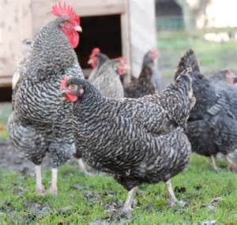
Advantages of free range system
  - Birds get balanced diet
  - Birds get enough physical exercise
  - Manure is well spread in the field
  - It is cheap in terms of feeding
  - It is time saving since the birds need little care
  - It is easy to control the poultry vice
Disadvantages of free-range system
  - It is difficult to keep records
  - It requires a very big piece of land
  - The poultry may easily destroy farmers’ crops
  - It’s hard to collect the eggs.
  - Birds can be easily pick worms and other parasites
  - Birds can easily be stolen or eaten by predators
- Deep litter system
This is a system of rearing a big number of birds under one shelter.
N.B: The house where such a practice is carried out is called a deep litter house
The floor of this house is covered with litter
Deep litter system is carried by commercial farmers

Materials used as litter

- Coffee husks
- Crushed maize cobs
- Wood shavings
- Dry grass

Qualities of good litter
- It should not be too dusty
- It should not become wet easily.
- It should be able to absorb moisture from poultry wastes
- It should not be too comfortable for birds
Importance of litter
- It helps to prevent eggs from breaking during laying.
- It keeps the floor of a deep litter house warm and dry
A diagram to illustrate deep litter system.
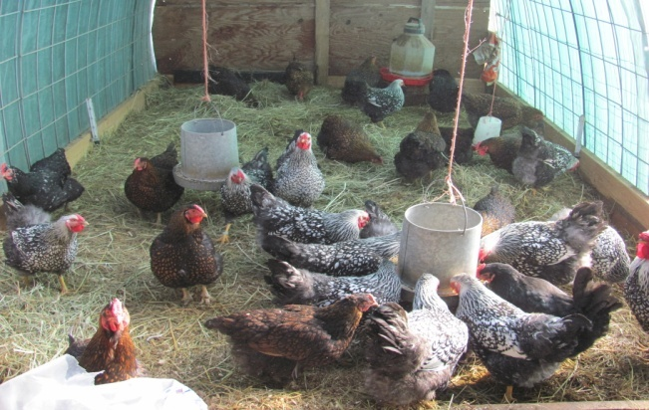

Advantages of deep litter system
  - Collection of eggs is easy
  - Many birds are kept in a small area
  - It is easy to feed birds in one place
  - Birds are protected from predators
  - Record keeping is easy
  - Birds cannot easily pick parasites
  - Chances of disease spread are reduced
  - It is easy to collect manure

Disadvantages of deep litter system
  - It is expensive to start and maintain the system
  - Much attention and care is needed
  - If litter stays for long it produces bad smell
  - It is tiresome to look after the birds
  - Vices such as egg eating, cannibalism,etc. may be developed by birds
  - Birds may not get enough exercise
  - Comfortable litter may lead the birds to become broody.
(c) Battery (cage) system
In this system, birds are kept in separate cages (one or two)
The floor slopes slightly so that when eggs are laid they roll into a wire trough
Droppings fall under raised cage and make the floor remain clean
Advantagesofbattery (cage) system
  - Food, water and eggs are hardly contaminated
  - Sick birds can be easily detected and removed.
  - Many birds can be kept on a small piece of land
  - Eggs laid remain clean
  - It is very easy to identify poor layers.
  - Birds are protected from predators
  - Poultry vices are reduced
  - It is easy to collect manure
  - Record keeping of individual birds easy
  - Diseases and parasites do not spread easily
Disadvantagesof battery (cage) system
  - It is very expensive (cages are expensive to construct)
  - Birds may not get a balanced diet
  - Much labour is needed
  - Birds do not get enough exercise
- Fold or pen system
In this system, birds are kept in a small structure called a fold or pen or ark
The fold or pen the birds are moved to new places daily.
The fold or pen provides shade and egg laying space for birds.
A simple structure of fold or pen

Advantages of fold or pen system
  - Birds are restricted and cannot destroy crops
  - Chickens feeds are not wasted
  - Manure is well spread on the farm
  - Chickens are safe from predators
  - Feeding is cheaper and birds get a balanced diet
Disadvantages of fold or pen system
  - It needs a very big piece of land.
  - Folds get old quickly due to frequent movement
  - More labour is needed to move folds every day
  - It is not applicable on hilly and swampy areas
  - It is very expensive to construct fold
  - Only few birds are kept
  - Birds do not get enough exercise

Simple diagram of alimentary canal
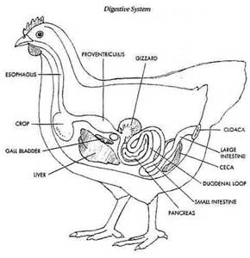
The digestive systems of a bird (Alimentary canal)
  - The digestive system of a bird (alimentary canal) consists of the following major parts namely; Beak, Gullet, crop, stomach, small intestine, large intestine, caeca, Gizzard and cloaca (vent), Beale
Functions of each part
(a) Beak – It picks food
(b) Gullet – It is a food passage to the crop
(c) Crop – It stores, moisture and softens the food before it goes to the stomach
(d)Stomach- it is where food is mixed with digestive juices.
(e) Gizzard – In this organ, food is crushed into small particles to help small stones called grit or pebbles
(f) Small intestines – Digestion of food is competed here and digested food is absorbed into blood stream
(g) Large intestines – absorption of water from undigested food takes place here.
(h) caeca- digestion of roughage takes place here by the help of useful bacteria
(i) Cloaca (vent) –it is a passage of eggs and droppings at different times.
Reproduction in poultry
Poultry reproduce by laying eggs

Reproductive system of a bird
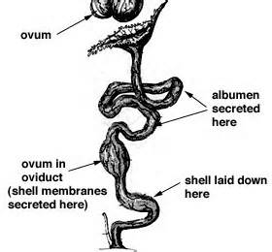
Functions of the parts
Ovary: to produce eggs or ova
Funnel’ (infundibulum): it is where egg yolk is produced and added to an egg.
Fertilization also takes place here
Magnum (Albumen producing region): It is where albumen is added to an egg
Isthmus: it is where shell membrane, water, air space, chalaza and mineral salts are added to an egg
Uterus (egg shell producing region)
It is where egg shell is added to an egg
Vagina: It is where pigments are added to an egg

An egg (fully grown/developed)
  - The structure of an egg consists of the following parts; Egg shell ,shell membrane, air space, albumen (egg white), chalaza, embryo or germinal disc
Cross section through an egg
Yolk

Egg shell Egg membrane
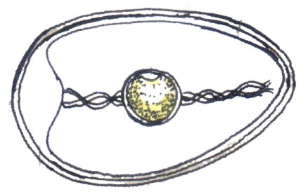
Air space
Chalaza Embryo (germinal disc)
Egg white (Albumen)
Functions of each part
Egg shell – It is made up of calcium
  - It protects the inner parts of an egg
  - It’s porous to allow gaseous exchange to take place
Shell membrane – To hold the inner contents of an egg.
Albumen (Egg white)
  - It is also called egg white
  - It provides proteins and water to the growing Embryo
Chalaza
  - It holds the yolk and embryo in position
  - Carries water and food to the embryo
  - Carries oxygen from the air space to the embryo
Air space
  - It provides fresh air (Oxygen) to the embryo
  - Takes carbon dioxide produced by the embryo
Yolk – It is also a source of proteins and fats for the growing embryo
Abnormalities in eggs
- Yolk less eggs
- Double yolk eggs
- Thin shelled eggs
- Eggs with blood spots
- Eggs with meat spots
- Eggs with soft shells
Factors that may lead fertilized eggs fail to hatch
- Eggs laid with two yolks
- Eggs with a lot of moisture content
- Eggs exposed to too much heat
- Failure of an egg to get enough oxygen
- Failure of an egg to get enough warmth
Incubation- This is the process by which a fertilized egg is given necessary conditions to hatch into a young bird
Incubation period – This is the time taken for a fertilized egg to hatch into a young bird
Incubation period for different birds
- Chickens – 21 days
- Ducks – between 30-31 days
- Turkeys – 28 days or 4 weeks
- Pigeon – 16 days ( 2 weeks, 2 days)
- Geese – 30 days
Types of incubation
(a) Natural incubation
This is when a mother hen sits on her eggs to enable them hatch.
- The broody hen usually comes off to feed, gets little exercise and in the morning to wet its feathers to prevent heat loss and add moisture to the eggs during incubation
Diagram of a hen incubating eggs A chick hatching from an egg
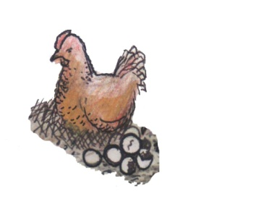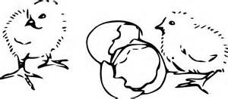
How to ensure effective natural incubation
- Use good fertilized eggs
- The place for incubation should be with dim light
- Protect the hen from rats, snakes etc which might eat eggs
- Provide a good, clean, dry nest that is comfortable for the broody hen
Advantages of natural incubation
    - It is cheap and easy to manage
    - Chicks get extra care from the mother hen
    - Chicks get protection from the mother hen
Disadvantages of natural incubation
    - Fewer chicks are hatched at a time
    - It can’t be used by commercial farmers
    - Eggs are not tested for their fertility
    - Some eggs are not hatched
    - Hens used may not be good for incubation
    - The birds can be attacked by snakes, wild cats and mites
b) Artificial incubation
This is a machine called incubator is used to hatch eggs
An incubator may provide all conditions that a broody hen provides
An incubator can use paraffin or electricity to provide enough warmth
A locally designed incubator uses paraffin and modern one uses electricity

An incubator
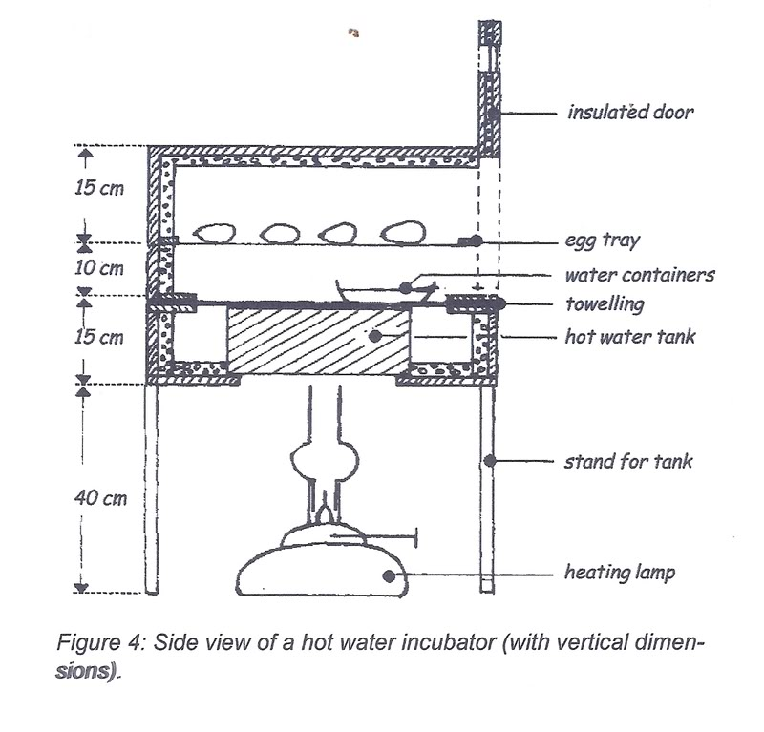
Advantages of Artificial incubation
    - Very many eggs can be hatched at a time
    - It is good for commercial farmers
    - Eggs are tested for their fertility in the process called candling
    - Temperature is maintained properly in an incubator by the use of a thermometer
    - All eggs are hatched since they are first tested for their fertility
Disadvantages of Artificial incubation
    - It is very expensive method of incubating eggs
    - It needs regular supervision
    - It needs skilled man power
    - It is tiring
    - Eggs can be affected in case of frequent black out or load shading
Brooding
Brooding is a process of giving special care to chicks below 8 weeks
Types of brooding
- Natural brooding
- Artificial brooding
- Natural brooding
This is a method where a hen takes more care of her chicks by providing warmth, security and food to them
Farmers may also support by providing more food and water to the mother hen and its chicks
When the chicks are big enough, they are left on their own
A hen looking after her chicks
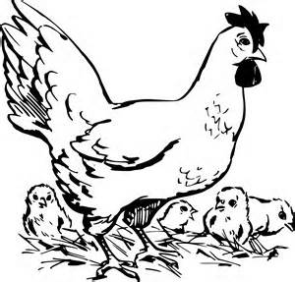
Advantages of natural brooding
  - The mother hen looks for food for its chicks
  - The mother hen provides security for its chicks
  - Toes and feather pecking are reduced among chicks
Disadvantages of brooding
  - Chicks may die due to poor protection
  - Chicks are exposed to predators
  - It is not carried out on large scale
  - It gives little profit
  - A mother hen may be stolen or eaten by predatorsleaving chicks without care
- Artificial brooding
This is where by chicks are kept in a special structure called a brooder
A brooder is a special house /structure designed to keep chicks below 8 weeks

Types of brooder

(a) Infra – red brooder
(b) Kerosene brooder

Infra – red brooder
Infra – red brooder: In this type, electricity is used as a major source of heat
Lamps are hung from the ceiling and adjusted (changed) from time to time as chicks grow
A simple diagram of infra-red brooder
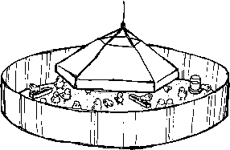
Kerosene brooder
In this type, farmers use paraffin lamps (lanterns) as sources of heat.
This type needs careful handling of lamps not to burn chicks and avoid accumulation of soot
The lamp should also be with guards to keep off chicks from being burnt
A layout of kerosene brooder
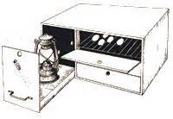
Management practices
  - Management practices are routine activities carried out on farm to increase on the quality of farm animals and their products

Common daily/routine activities include

  - Record keeping
  - Regular cleaning
  - Vaccination
  - De-worming
  - Culling
  - Dusting
  - Egg collection
  - Debeaking
  - Cross breeding
  - Housing
  - feeding

Feeding poultry
Reasons for good feeding
  - For proper growth
  - To get high quality eggs and meat
  - To boosts their immunity
Classes of food given to birds
  - Birds need mash containing all classes of food such as; proteins, vitamins, carbohydrates, minerals, water, etc.
Proteins: (body building food)
  - Enables birds to grow well and put on flesh (meat or chicken)
  - Crushed fish (mukene), Soya beans etc are rich source of proteins
Vitamins: keep the body healthy or protect the body from diseases
  - They are healthy/protective food
  - Green vegetables are rich sources of vitamin
Carbohydrates: (energy giving food)
  - Provide the birds with energy
  - Maize bran, cassava, rice, millet, sweet potatoes etc are rich source of carbohydrates

Minerals: Calcium makes the bones and eggs shell strong
  - Calcium, iron, crushed shells, iodine, dried animal blood m-(iron) etc are examples of minerals
  - Oyster shells, Green vegetables, common salts are also rich source of minerals

Water
  - Water promotes easy digestion of food
  - Maintains body temperature of a bird
Chicken mash
  - Chicken are fed on different types of food called mash. (mixture of minnow (Mukene), maize bran (outer layer of the grain) Oyster etc depending on what age the types of birds are;
  - Chicken mash is grouped into four (4) types namely; chicken and duck mash, Growers mash, Layers mash and broilers mash
Chick and duck mash
  - It is given to chicks and ducklings which are 1 day – 8 weeks
  - This mash contains high protein content to support fast growth in chicks
  - Each chick needs about two grammes (2gm) of mash per day
(b) Broilers mash
  - It is prepared for chicken that provide meat (chicken)
  - It is introduced to broilers from 8 weeks on wards
(c) Growers mash
  - It is given to growing birds e.g. layers from 8 weeks to about 16 weeks (8 – 16) weeks and Broilers between 4 – 8 weeks
(d) Layers mash
  - It is prepared for laying chicken
  - It is introduced to layers at 16 weeks

Summary table
Mash | Bird’s age
Chick and duck mash  Layers mash  Broilers mash | Chicks and ducklings of 1 day to 8 weeks (two months)  Layers from 8weeks – Broilers from 4-8 weeks  Broilers to 8 weeks on wards

Feeding tools
  - The mash given to chicken must be always put in a clean containers called feeding troughs
  - A good feeding trough should be constructed with a spinning/rotating handle in the middle to prevent birds from stepping on and spoil or contaminate the mash
Simple diagrams of feeding tools
Feeding trough Drinking trough(conical drinker)
Spinning/rotating handle chicken mash water conical
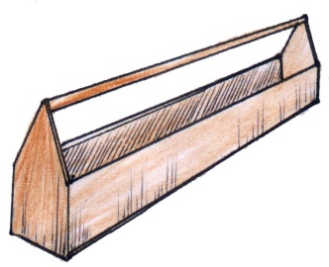Wooden feeding trough 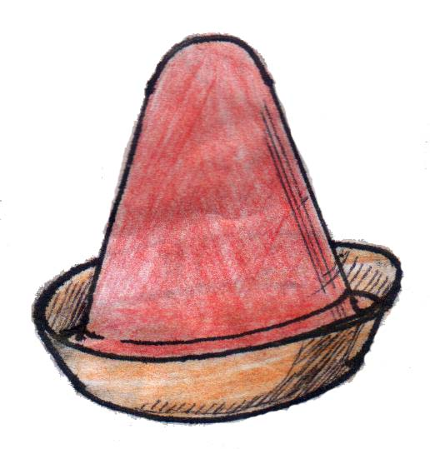
General practices in feeding poultry
  - Give correct feeds to the right type of a bird according to age and products
  - Introduce new feeds gradually (slowly)
  - Measure/record and give correct amount of feeds per day
  - Contaminated food water should not be given to birds
  - Provide fresh greens in the daily diet of birds
  - Cull the birds
Housing poultry
Reasons for proper housing
  - To prevent loss of eggs
  - To prevent the birds from being stolen
  - To protect the birds from predators

Qualities of a good poultry house
  - It should be well ventilated to allow free exchange of gases
  - It should have enough light to enable the birds to see feeds and water
  - It should have enough space for the birds
  - It should have strong doors
  - Its roof should be leak proof
  - It should be free from dampness or moisture
  - It should be free from diseases and parasites etc
Selection of birds for breeding
Means choosing the best bird for breeding or reproduction
Select the best quality birds which:
- Grow fast
- Lay many eggs
- Produce good meat
- Are resistant to diseases
Cross breeding
This is the process of mating birds that are not related to each other e.g. pure local + pure exotic breed = cross breed
Advantages of cross breeding
- They grow fast and are large like the exotic breeds
- They lay a lot of eggs
- They produce soft meat like exotic breeds
- They are resistant to diseases like local breeds
- They are resistant to droughts etc
Poultry vices
These are bad habits developed in poultry

Common poultry vices are;

- Egg eating
- Feather pecking
- Toe pecking
- Cannibalism

Causes of poultry vices
  - Over-crowding of birds (too many birds in a small area)
  - Boredom in the house (lack of what to do)
  - Failure for a farmer to provide enough and balanced food
  - Failure to remove damaged eggs immediately from poultry house
  - Failure to collect eggs regularly from the poultry house
Prevention/control of poultry vices
  - Carryout de-beaking
  - Collect eggs regularly from laying boxes
  - Darkening the laying boxes
  - Provide the birds with enough food.
  - Provide food to the birds in time
  - Remove broken eggs from the poultry house as soon as possible
Diseases and parasites of poultry
General causes of diseases and parasites
  - Poor feeding of poultry on already contaminated food
  - Poor housing structure for birds
  - Dirty houses lead to an outbreak of diseases and parasites
Dangers of diseases and parasites
  - Death may occur
  - Lower the quality of products
  - Reduces the bird’s rate of growth
Common diseases of poultry
Disease cause
  - Coccidiosis Protozoa
  - Newcastle virus
  - Fowl pox virus
  - Fowl typhoid bacteria
  - Avian leucosis
  - Pneumonia Bacteria
Pneumonia
  - It is caused by bacteria
  - It attacks the lungs
Signs and symptoms

  - Difficulty in breathing
  - Coughing
  - Lack of appetite
  - Mucus from the nose

Prevention and treatment

  - Keep the poultry house clean
  - Make the house well ventilated
  - Separate diseased birds from healthy ones

  - Early Treatment with antibiotics

Parasites - These are living organisms which depend on other living organisms for food and shelter.
Types of parasites
- Ecto – parasites (External parasites)
- Endo – Parasites (internal parasites)
Ectoparasites
These are parasites which live on the body of a host

Examples of ecto parasites of poultry
Fleas, mites, lice

Endo - parasites
These are parasites that live inside the body of a host.
  - Common examples are: Round worm, Tape worm, Threadworm etc
Types of parasites | Examples | Effects
Ecto parasite | Fleas  mite  fowl lice | - They create wounds on skin of birds  - They cause itching and scratching of body that may lead to loss of feathers  - They suck blood from the birds making them anaemic  - Egg laying is greatly reduced  - Mites cause a disease called mange
Endo parasites | Tape worm  Round worm | - They cause stunted or poor growth  - Egg laying is reduced
Control/Treatment of parasites in poultry
  - Use of pesticides for external parasites
  - Carry out regular deworming to kill internal parasites.
  - Clean poultry houses regularly.
  - Apply Vaseline jelly on affected parts of the body caused by mites and fleas
  - Give birds clean water and food
  - Give birds water and food in clean troughs
Keeping farm records
Farm records are written information showing activities carried out on a farm.
Types of records
- Health records
  - Feeding records
  - Operation records
  - Production records
  - Sales and expenses records (expenditure) etc
Importance of keeping records on a farm
  - It helps the farmer to plan for his farm.
  - It helps the farmer to know if the farm is making profits or losses
  - Help the farmer to know the birds to cull
  - Farmers are able to know the sales and expenditure
  - Help a farmer to acquire loans from a bank
  - Help a farmer to be taxed fairly by government.
A format of production record
Namirembe Parents’ School farm
P.O. Box 29928
Kampala
(a) month: March 2011
(b) Breeds of chicken: white leghorn
(c) Age of the flock: 18 weeks
(d) Number of birds 500
Number of eggs broken | Date | Morning | Afternoon | Total | Remarks
50 | 24.03.11 | 250 | 200 | 450 | Poor handling
- | 25.03.11 | 300 | 200 | 500 | Careful handling

TOPIC TWO: SOCIAL INSECTS
Social insects are insects that live and work together
Examples of social insects include:
Honey bees
Wasps
Termites
Bee keeping [apiculture]
Bee keeping: is the rearing of bees.
Apiculture: is the rearing of honey bees on a large scale.
Importance of bees to plants and people
People
  - People get honey from bees
  - People get wax from bees.
  - Bee farming creates employment to people
Plants
- Bees help in pollination
The life cycle of a honey bee
  - The honey bee undergoes complete metamorphosis
  - The Queen lays eggs
  - The larvae are developed from the eggs and are fed by the worker bees
  - They change in pupae
  - The pupae develop into adult bees
Simple diagram to illustrate
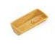

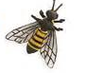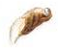
Types of honeybees
  - There are three types of bees in each colony namely;
    - Worker bees (b) Drone bees and (c) Queen bees
      - Queen bee
  - It is the head of the colony
  - The Queen bee is formed when female grub is fed on royal jelly throughout its life cycle.
  - Its main function is to lay eggs
  - It is a female fertile bee
  - It is the biggest in the colony
  - It can last 4 - 5 years
  - Its abdomen is longer than that of others
  - Its fed on special food by workers called royal jelly
Simple diagram to illustrate
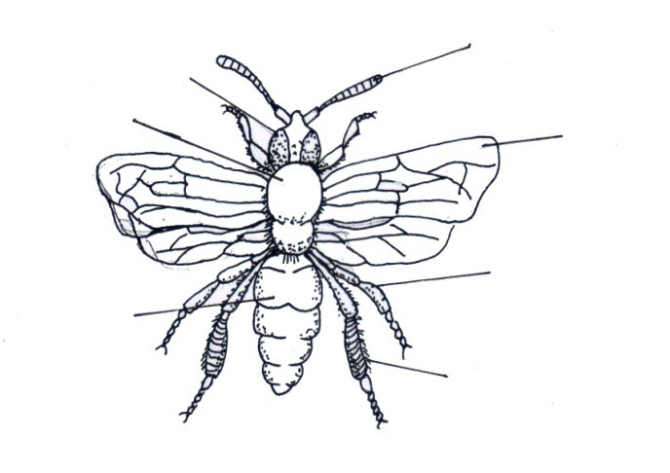
Wing
antenna
compound eye
thorax
abdomen
leg
- Worker bees
- These are female sterile bees
- They are the smallest in the hive
- They have hair on the back and on their legs
- They have a sting
- They are many in the hive
- They have a sting at the end of their abdomen
Roles of a worker (s) in the hive
- It feeds the Queen bee on a special food called royal jelly
- It feeds the grub
- Protects the Queen and the hive
- They make honey
- They repair the hive
- They clean the hive
- They regulate temperature (They fun the hive)
Simple diagram of a worker bee
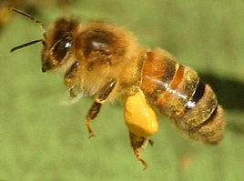
Diagram showing the parts of hide leg of a worker bee
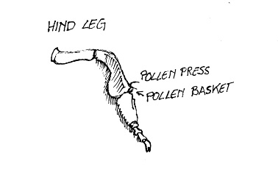
- Drone bee
- It is a male bee in the hive
- It is bigger than a worker bee in the hive
- Its main work is to mate with the queen bee.
- It makes a buzzing sound
- It’s the most hairy bee in the hive
Simple diagram of a drone bee
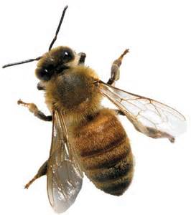
A swarm – is a large cluster or group of bees
Swarming
- This is the massive movement of bees from one place to another looking for a better hive.
Reasons for swarming in bees
- When another Queen is formed
- For the queen bee to mate.
- When they are overcrowded in the hive
- When the hive is leaking or damaged
- When there is a bad smell around the hive
- Death of the Queen
- Overheating of the hive by direct sun shine
- When they are disturbed by enemies
- When there is shortage of water
- Noisy places can lead to bee swarming
- Area with a lot of smoke
- Dampness of the bee hive
- Lack of flowering plants in the area
Enemies of bees
- Ants
Many types of ants attack bees in their hive e.g. the wood ants and safari ants
How to protect bees from ants
- Hang the hive from between poles
- Put or/smear the bases of the poles with grease.
- Place grease on the wires, This can prevent the ants from reaching the hive
(b) Honey Badgers
- These spoil the hives, kill bees and eat the honey

Other pests include
- Hive beetles
- Pirate ants
- Wasps
- Hawk moths
- wax moth
Modern methods of keeping bees
Bees can be kept using two types of bee hives namely
- Traditional bee hive
- Modern bee hive
A hive – This is a structure where beeslive.
(a) Traditional bee hive
This is the type of bee hive made up of local materials such as hollow logs, grass, woven sticks, cow dung, clay etc
When the bee hive is made, it is hung up in places like trees
Examples of local hive
- Kigezi bee-hive
- Dug out log hive
Advantages of traditional (local) bee hive
- It is cheap
- It is easy to make/construct because materials are locally available
Disadvantages of local bee hive
- The honey collected is always dirty
- Colony cannot be inspected
- The hive is damaged when harvesting honey
- The brood is damaged when harvesting honey
- Too much honey can break the hive
(b) Modern bee hive
- These are constructed out of materials and piece of wood
Common examples of Modern bee hive

- Top bar hive
- Box hive
- Tin hive

Chambers’ in a modern bee hive
- They are constructed with chambers called brood and honey chambers
- Two chambers are separated by a metal called Queen excluder
- The queen excluder has holes of given sizes through which only workers pass through to look after the Queen
- Once the Queen is put into the brood chamber, it cannot move to the honey chamber because the Queen is too big to pass through the small holes
- The queen excluder prevents the Queen bee from entering the honey chamber to eatthe honey
Internal structure of a modern bee-hive
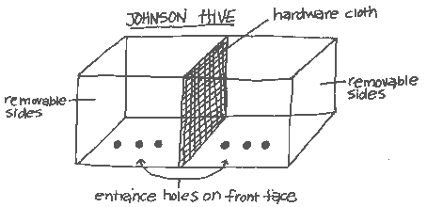
Top bar hive Box hive
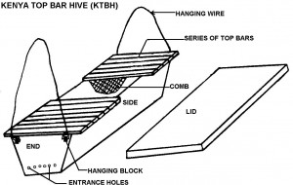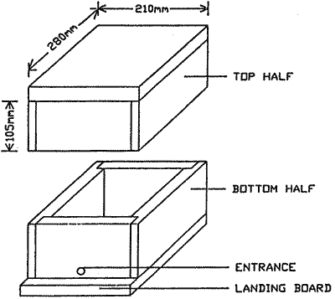
Advantages of modern bee hive
- The honey collected is always clean
- The eggs, larvae and pupae are not disturbed
- Number of bees continue to multiply
- Honey combs which are ready for harvesting can be removed and those which are not ready can be replaced back
- Honey and wax can be inspected separately
- Modern bee hives are long lasting
Disadvantages of modern bee-hive
- It is very expensive
Harvesting honey
Honey should be harvested in the evening when it is cool and all the bees have settled inside the hive
When harvesting honey, the farmer must have the following equipment
- A bee veil
- gloves
- A bucket
- A suitable protective clothing (Overall)
- A smoker
- Gum boots
- Knife

Uses of each equipment above
Bucket:it is used for collecting honey.
Bee veil: protects the face of a honey harvester from being stung by worker bees
Bee keeper’s gloves: protect hands of a honey harvester from being stung by worker bees
Smoker: for smoking the hive to calm the bees
Knife: for cutting honey combs
Gum boots: To prevent worker bees from stinging the feet of a honey harvester
Steps followed when harvesting honey
- Smoking the hive
- Putting the hive down
- Opening the hive
- Cutting the honey combs

A simple diagram of a farmer ready to harvest
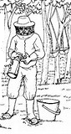
Factors to consider when harvesting honey
- Don’t frighten the bees while harvesting
- Don’t kill bees while harvesting
- Dress properly in suitable clothes
- Use a smoker
- Bees should not be crushed while harvesting honey
Honey extraction
Honey extraction is a process of separating honey from honey combs.
Method of extracting honey
- By floating the wax
- Centrifuging method
- Pressing the wax method
Products got from bees
- Honey
- Bee wax
Uses of honey to people
- honey is eaten as food
- It is used to sweeten tea.
- It is used as medicine for cough.
NB: the food value got from honey is carbohydrates
Products from bee wax
- Candle wax
  - Polish for wood, floor and shoes
  - Chewing gum
Care and management of bees
Siting the bee hive. This is simply the selecting a suitable place in which to put the hive
A place in which a number of hives are kept is called an apiary
Factors to consider when siting hives
- Bees should be sited away from houses, roads and animals
- Bee hives should be put in places near water sources
- Places with flowering plants
- Sheltered places
- Places with short grass
(b) Stocking the hive
This is a process of encouraging bees to occupy an empty hive
It is done in various ways:
(a) Use of a catcher box
(b) Use of a swarm catching net
(c) Setting up the hive in its permanent place, smear the inside parts with wax and wait bees to come for their own.
NB:the handle of a swarm catching net can be made longer to catch a higher swarm
A swarm catching net
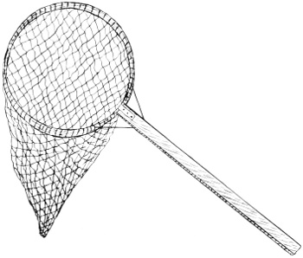

Feeding bees
- Bees naturally feed on nectar from flowers
Conditions that make bees be fed on supplementary food
(a) When they are new in a hive (new colonies)
(b) During the drought conditions
(c) To encourage multiplication
Examples of supplementary feeds
(a) Syrup (ordinary sugar mixed water)
(b) Ordinary water put in a container at a distance of 10m from the ordinary hive
Handling of bees by a bee keeper (Three occasions)
- When harvesting honey
- When inspecting the hive either to know whether he can harvest honey or there are problems
- Catching bees for stocking
SUMMARY OF TOPICAL QUESTIONS

TOPIC THREE: MEASURES
Regular shaped objects
These are objects which have proper or regular shape. Examples include: - a cube, a cuboids, a brick, blocks, tins and other cylinders.
Measuring regular shaped objects.
- Length
Length is measured in the following units
- millimetres (mm)
- centimetres (cm)
- decimetres (dm)
- metres
- decametres (Dm)
- Hectometres (Hm)
- Kilometres (Km)
- The most commonly used units for measuring length are centimtres, metres and kilometres
- The smallest unit for measuring length is millimetre.
- The biggest unit for measuring length is kilometre
- The basic nit for measuring length is metre
Area:
- Area is the total space occupied by a figure (two dimensional figure)
Are is measured in square units
In two dimensional figure, the longer side is the length while the shorter side is the width.
Width

Length

Volume
- Volume is the space occupied by an object.
- Volume is measured in cubic unit i.e. cubic metres, cubic centimetres or cubic millimetres.
- Volume s also measured in litres, milliliters and centiliters (cl)

Finding volume of regular shaped objects
The volume of regular objects like, cuboids e.g. boxes blocks bricks etc, can be found after knowing their length, width and height.

Height (H)

Length (L) width (W)

Volume = Length x width c Height
Exercise
- Find the volume of the figures.
- (b)

2cm 5cm

5cm 4cm3cm1cm

- Find the volume of a brick of length 6cm width 4cm and height 3cm.
- Find the area of a cube whose side is 3cm.
Irregular objects
Irregular objects are objects without regular shape.
Examples include stones, keys, needles, soda bottle etc
Finding volume of irregular objects
- The method of finding the volume of irregular objects is measuring by displacement.
- There are two instruments used in measuring by displacement i.e.
- the measuring cylinder
- the over flow can or eureka ca
Using a measuring cylinder
Step I
Pour water into a measuring cylinder so that it is a half full.
Record the volume of water say 30cc
Step II
- Get a stone and tie some thread around it
- Lower the stone into the measuring cylinder so that the stone is covered by water.
- Record the volume of water again say 35cc.

40cc 40cc
1st 30cc 30cc
2nd level
1st level
20cc 20cc
10cc 10cc

Volume of the stone = 2nd level – 1st level
= 35cc – 30cc
= 5cc
The volume of water is 5cc because the amount of water displaced is always equal to the volume of the irregular object.
Using an overflow can (eureka can)
- Fill the overflow can with water so that the water pours out through the spout until it is at the same level of the spout.
- Put a stone whose volume you want to find and lower it into the can.
- The water will overflow and pour into the measuring cylinder.
Find the volume of the stone by reading the level of water in the cylinder.
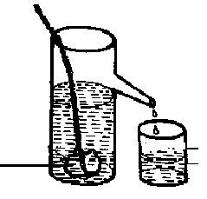
The volume of the irregular object is 10cc.
Difference between capacity and volume
Capacity is measured in litres while volume is measured in cubic units
Capacity refers to amount of a liquid a container can hold while volume is the space occupied by a substance.
Weight
- Weight is the gravitational pull acting on an object.
- Weight of an object depends on three things i.e. its size, the substance form which it is made and the gravitational pull on it.
- Weight changes according to the distance between the centre of the earth and the body of object.
Note: Objects weigh less on the moon that on earth because the moon is for away from the centre of the force of gravity from the earth which pulls it.
- When you lift or pull something you are overcoming the force of gravity.
- It is difficult to push a wheel barrow uphillbecause you are opposing the force of gravity.
- It is easier to push a wheel barrow downhill because you are helped by the force of gravity.
- Weight is measured in units called Newtons (N) but (10N = 1kg) or (1N = 100g)
Weight is measured using an instrument called spring balance
Diagram of a spring balance
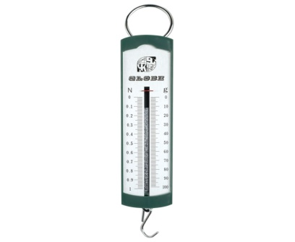
Mass
Mass is the quantity of matter an object contains.
Mass is constant because it doesn’t depend on the force of gravity
A body can have the same mass on land and on the moon
- Mass is measured in grammes, kilogrammes, milligrams etc
- The basic unit for measuring mass is grammes (grams)
Examples of machines used for measuring mass.

- Beam balance (b) set of scale
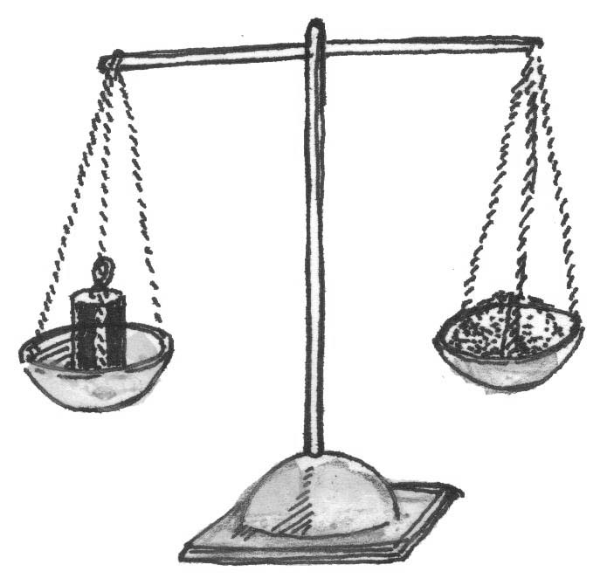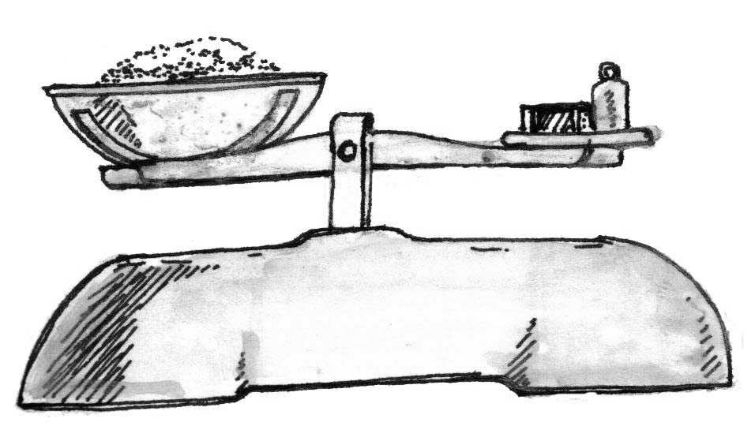

- scale balance
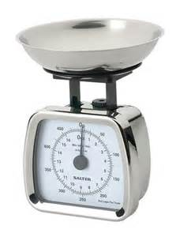
Differences between mass and weight
Mass Weight
Measured in kilograms Measured in Newtons
Measured using beam balance Measured using a spring balance
It is constant Keeps changing from place to place
Density
- Density is the mass of a substance per unit volume
- Density (D) = mass (M)
= Volume
D = M
V
Density is measured in grams per cubic centimetre (g/cm3)
Table showing densities of some substances.
Substance | Density
Gold  Mercury  Lead  Silver  Copper  Aluminium  balss  Brass  Rubber  Salt solution  Water at 4c⁰  Ice  Methylated spirit  Kerosene  Alcohol  Pertrol  Cork  Iren  Air  hydrogen | 19.3  13.6  11.3  10.5  8.9  2.7  2.6  8.3  1.3  1.2  1.0  0.92  0.83  0.8  0.8  0.7  0.24  7.8  0.0012  0.00009
- From the above table, aluminium has the least density among metals and that is why it is used. for bodies of aero planes.
- Objects which are less dense than water will always float on water e.g. cork, ice, wood etc
- Substances which are denser than water always sink in water e.g. iron, brass, nails, stones, sand etc
Kerosene, petrol and most oils always float on water because they are less dense than water.
A hydrometer is an instrument used for measuring the density of different liquids e.g, beer, wine, acids in batteries etc
A special instrument used for measuring density of milk is called lactometer
Finding Density
Example I
Find the density of an object of mass 150g and volume 3cc.
Solution
D = M mass = 150g
V volume = 30cc
D = 5g/cc
D = 150
30
Example 2
If the mass of the cuboid is 48g.
Find its density

4cm

2cm
6cm
Now, D = M mass = 480g
V volume = 48cm³
Solution
Here, we are not given the volume so we first find the volume
V = LxWxH
= 6x2x4
= 48cm
Example 3
Calculate the volume of a stone of mass 48g and density 6g/cc
Solution
We are asked to find volume
M=48g
D=6g/cc
V=M
D
48g
6g/cc
=8cc

Note: We can use the triangle below to help us to remember the formula used.

M

D V

D = M
V
M = D x V
V = M
D
Floating and sinking
Floating is when an object is put in water and it stays on top of a fluid.
- Objects float on water because they are less dense than water.
- The density of water is 1g/cc and therefore, objects whose density is less than 1gg/cc float on water.
Examples of things that float on water
Cork, plastic, rubber, boats
Wood, sponge, a leaf, feathers etc
Sinking
- Sinking is when an object is put in water and it goes to the bottom of the water.
- Objects sink in water because they are denser than water.
- Objects whose density is more than 1g/cc sink in water.
Examples
- stones, sand, soil, metal, glass, nails etc
Note: A sinking object displaces water equal to its volume while a floating object displaces water equal to its weight
TOPIC FOUR: IMMUNIZATION
What is immunization? This is the introduction of vaccines to the body.
Types of immunization
- Primary immunization this is done to all infants or children below 5 years
- Mass immunization this is done to all people when there is an outbreak of a disease in an area
- Booster immunization this is done to maintain the required amount of antibodies in the body of a person e.g. administration of T.T vaccine to teenage girls and pregnant mothers.
Importance of immunization
- Protect the people from acquiring dangerous disease
- Reduce infant mortality rate.
- Enables the body to resist diseases
Immunity
This is the body’s ability to fight or resist disease or infection.
Types of immunity
- Natural immunity: This is acquired without receiving any vaccine.
- Artificial immunity: This is when vaccines are introduced into one’s body oral method.
How the body acquires natural immunity
- Through suffering and recovering from an illness.
- From the mother to her baby through breast feeding
How the body acquires artificial immunity
- Through immunization
Vaccines
Vaccines are medical drugs used for immunization

Methods of vaccine administration
- Oral administration
- Injection method
Types of vaccines
- Toxoid vaccines
- Attenuated/living vaccines
- Dead/ killed vaccines
Examples of vaccines
BCG Vaccines
- It provides immunity against tuberculosis
- It is injected on the right upper arm at birth
- It is administered by injection method
- It is injected once that is it has only one dose

Polio vaccine
- It provides immunity against polio.
- It is administered by putting into the mouth
- Four does are given at different intervals
1st dose at birth (polio 0)
2nd dose at 6 weeks (polio 1)
3rd dose at 10 weeks (polio 2)
4th dose at 14 weeks (polio 3)
Measles vaccine
- It provides immunity against measles.
- It is injected on the left upper arm at nine (9 months)
- One dose of measles vaccine is applied.
Pentavalent vaccine (DPT-HepB+Hib)
- It provides immunity against Diphtheria, whooping cough, Tetanus, Hepatitis B, HaemophilusInfluenza B
- It is injected on the left upper thigh
- Three doses are given at different intervals
- 1st dose at 6 weeks
- 2nd dose at 10 weeks
- 3rd dose at 14 weeks
Note: HepB is the vaccine for hepatitis B whileHib is a vaccine for haemophilusinfluenza B
HPV Vaccine
- HPV in full stands for Human Papilloma virus
- -It is used to immunize against cervical cancer.
- -It is administered to girls from9 years onwards
Pneumococcal conjugate vaccine (PCV)
- -It is immunized against pneumonia and other pneumococcal diseases
- -It is administered to babies by injecting on the right outer thigh.
- -There are doses of PCV administered to babies
- First dose at 2 months
- Second dose at 4 months
- Third dose at 6 months
- Forth dose at 12 to 15 months
Some effects of PCV after administration
- Swelling at the injection site
- Mild fever
- Loss of appetite
- Vomiting
- Redness at the injection site
N.BIf these symptoms persist visit a medical doctor immediately
Yellow fever vaccine
- Yellow fever vaccine is used to immunize against yellow fever
- Yellow fever is caused by a virus transmitted by an infected female tiger mosquito
- Yellow fever vaccine is an example of attenuated vaccine or living vaccine
- Yellow fever vaccine is administered through injection on the right upper arm
People who should be given yellow fever vaccine
- People who work in research laboratories
- People who travel to areas with yellow fever
- Children who are 9 months and above
N.B People who travel to areas with yellow fever should travel after 10 days of immunization
- They should also be given international certificate of immunization
- The international certificate of immunization becomes valid after 10 days of immunization and expires after 10 years.
- The people who continue to stay in areas with yellow fever after 10 years should be given yellow fever booster vaccine
People who should not receive yellow fever vaccine
- People who are allergic to eggs
- People with cancer
- People with weak immunity
- Children below 9 months
- Breast feeding mothers
N.B People who are allergic to eggs can be immunized if they are in places affected by yellow fever. But the doctor can give a vaccine in small doses to avoid serious reaction.

Childhood immunisable diseases

- Measles
- Tuberculosis
- Poliomyelitis
- whooping cough
- Rota Virus Diarrhoea
- Pneumococcal Pneumonia
- Tetanus
- Hepatitis B
- Haemophilus influenza B
- Diphtheria
- Tetanus

Other immunizable diseases
- Pneumonia
- Yellow fever
- Cervical cancer
- Meningitis
- Rabies
TUBERCULOSIS (TB)
- It is caused by bacteria
- It attacks the respiratory system
Signs of tuberculosis
- chronic cough
- loss of weight
- A lot of sweating at night
Symptoms
- mild fever
- pain in the chest or in the upper back

How it is spread
- It spreads to a healthy person through droplets of mucus from a sick person through air.
- It can also spread through sharing cutlery, cups and plates with an infected person
- People can also get it through drinking un boiled milk from tubercular cows
Treatment of Tuberculosis
- Carry out immunization
- Treat with antibiotics
- Visit a healthy worker for correct treatment
- Avoid sharing cutlery, cups plates etc with a sick person
- treat the patient with isolation
MEASLES
- It is caused by a virus
- It is an air borne disease (spread through air)
- It affects the skin and the lungs
Signs measles
- Sores in the mouth
- runny nose
- skin rash
- dry cough
- red eyes
Symptoms of measles
- High temperature
- Itching rash
- Loss of appetite
- weakness
Prevention of measles
- Isolate measles victims
- Immunize children at 9 months
Poliomyelitis (polio)
- It is caused by a virus
- It spreads when one drinks water contaminated
- It affects bones especially the limbs.
Signs and symptoms
- Paralysis and weakness of one or more limbs
- lameness
- fever
Prevention and control
- Immunize children with polio vaccine.
- Drink safe clean water
Tetanus
- It is caused by a bacteria found naturally in the soil
- The bacteria enter the body through fresh cuts or wounds.
- IN new born babies, it can enter through the umbilical cord if it is cut with a dirty or unsterilized instrument like a razor blade.
Signs and symptoms
- Stiff muscles all over the body
- Spasms when touched.
- The baby stops suckling the mother’s breasts
Prevention and control
- Immunization with three doses of DPT vaccine at an interval of one month starting at 6wks or 1 ½ months.
- The vaccine is administered by injection on the left upper arm
- Girls and women between 15years and 49 years of age are given tetanus toxoid vaccine to prevent their babies from getting tetanus and also the mothers.
- All pregnant women receive tetanus toxoid in order for their unborn babies to get immunity against tetanus.
Note: DPT vaccine is given to babies at 6 weeks because babies are born with immunity against Diphtheria, pertussis and tetanus that lasts six weeks.

Whooping cough (pertussis)
- It is caused by bacteria and spread through air by coughing
Signs and symptoms
- Coughing spells which end up in vomiting
- Gasps for breath
- Running nose
Prevention and control
- Immunization with DPT vaccine
- It is administered by injection on the left upper arm
- The vaccine is given in three doses at an interval of one month beginning at 6 weeks.
Diphtheria
- It is caused by bacteria spread through air by coughing of an infected person.
Signs and symptoms

- Sore throat
- swollen neck

Haemophilus influenza type B
This disease is caused by bacteria and prevented using Hib vaccine
Hepatitis B
It is caused by a virus and spreads through body contact with infected body fluids.
Signs and symptoms
Passing out dark urine
Nausea
Vomiting
Jaundice
Fatigue
Muscle and joint pain
Prevention
Immunize babies with Hep B Vaccine

SUMMARY TABLE
Disease | Vaccine | How it is administered | Doses | At what age
Tuberculosis | BCG | Injection on the right upper arm | 1 | At birth
Polio | Polio vaccine | Drops in the mouth | 4 | 1st dose at birth  2nd dose at 6 weeks  3rd dose at 10 weeks  4th dose at 14 weeks
Diphtheria  Whooping cough  Tetanus  Hepatitis – B  Influenza – B  Haemophilus | DPT-  HepB+  Hib(Pentavalent vaccine) | Injection on the left thigh | 3 | 1st dose at 6 weeks  2nd dose at 10 weeks  3rd dose at 14 weeks
Measles | Measles vaccines | Injection on the left upper arm | 1 | At 9 months

Roles of individuals families and communities I immunization
Families
- Taking their children for immunization
Individuals
- Helping to identify children who have not been immunized in the community
- Advising members of the community to Immunize their children
- Taking their children for immunization
- collecting information about immunization in an area using it to educate people
Communities
- setting up immunizationcentres
- Encouraging families to take their children for immunization
- contributing money to use on immunization
- Inviting health workers to talk to the members on immunization
- Reporting outbreak fimmunisable disease in the area.
Children
Taking their siblings for immunization
Reminding their parents about immunization days
Helping to put up notices about immunization programmes
Child health card
A child health card is a document that contains the child’s bio data and immunization status.
Importance of child health
- Monitor the growth of a child.
- It reminds the parent the next date for immunization.
- It helps the doctor to know which dose has been given and what is remaining.

Government and non – governmental organizations which help to carry out immunization activities in Uganda
- Ministry of health
- UNEPI – Uganda national Expanded Programme on Immunization
Roles of UNEPI
To organize immunization programmes
To supply vaccines to immunization centres
Setting immunization schedules
Activity
- What is immunization?
- Define the following terms

- Immunity
- Anti – bodies
- vaccines

- Name the two types of immunity.
- What is natural immunity?
- Give the meaning of artificial immunity.
- State two ways the body may acquire natural immunity
- How does the body acquire artificial immunity?
- State two methods of administering vaccines in the body
- Name any four immunisable diseases.
- How is polio vaccine administered?
- Name one immunisable disease administered to people at the age of 9 months.
- Name the vaccine which provides immunity against Diphtheria, whooping and Tetanus.
- State any two importance of a child health card.
- Write UNEPI in full.
- Write NIDs in full
- Name any two domestic animals that are vaccinated (Immunized)
- State any two importance of immunizing people
- Why does immunization start at birth?
- State the diseases whose vaccines are given more than one disease.
- Name the vaccine administered orally.
- Why is the first polio vaccine given to a child at the age f 6 months and not at birth?
- Why is a measles vaccine not given soon after birth but given after nine months?

TOPIC FIVE:THE DIGESTIVE SYSTEM
The digestive system of human being is made up of tissues and organs which take part in the digestion of food,
It is a system that deals with the breaking of food and its use in the body.
The long muscular tube runs through the body from the mouth to the anus is a part of digestive system called the Alimentary canal which is 10metres long. It is where digestion of food takes place.
DIGESTION
This is a process by which food is broken down into soluble particles which can be absorbed into blood stream
The process by which food is taken into the body is called ingestion
Digestion begins in the mouth and ends in the ileum
There are two types of digestion in the alimentary canal namely:

-Mechanical digestion/ physical digestion
-Chemical digestion

Mechanical digestion: This is the breaking down of large molecules of food into simpler molecules by the help of the teeth.
Mechanical digestion is called a physical change because the physical nature of food remains unchanged
Chemical digestion: This is the breaking down of large food molecules into soluble substances by the help of enzymes
Enzymes
Enzymes are biological catalysts that speed up the rate of chemical digestion
Characteristics of enzymes
- Enzymes work best under suitable temperature range
- They are normally destroyed by heat
- Each enzyme digests only one class of food.
- Enzymes work best under suitable conditions
Conditions under which enzymes work
Alkaline conditions (PH)
Acidic conditions (PH)
N.B Enzymes in the mouth, duodenum and the ileum work under alkaline conditions
2. Enzymes in the stomach work under acidic conditions
Role of enzymes
To speed up (increase) the rate of chemical digestion
The alimentary canal
This is a long muscular tube along which food moves from the mouth to the anus.
How does food move in the alimentary canal?
Food moves along the alimentary canal through peristalsis
Peristalsis is the wave like movement of food through the alimentary canal
Parts of the alimentary canal (tube)

- mouth
- Gullet (oesophagus)
- stomach
- duodenum
- ileum
- colon
- rectum
- anus

The structure of a human digestive system consists of the following parts namely:

- mouth
- gullet (oesophagus)
- liver
- stomach
- spleen
- pancreas
- gall bladder
- bile duct
- Duodenum
- small intestine (ileum)
- large intestine (colon)
- appendix
- rectum
- Anus

The structure of a human digestive system
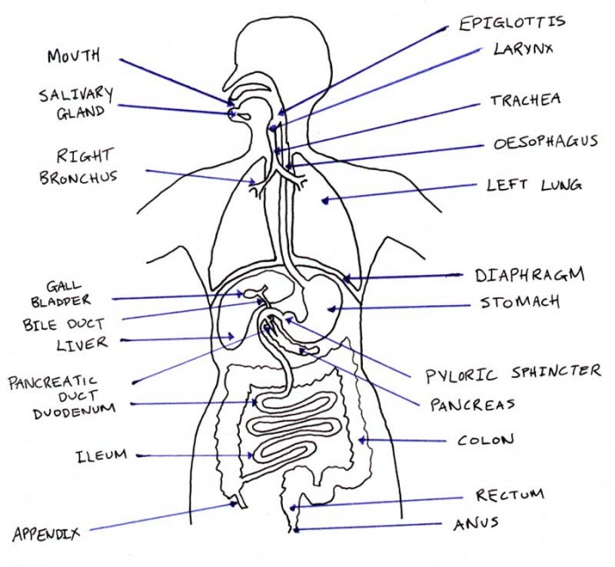
Activity
- What is digestion?
- Where does digestion of food

  - Begin?
  - End

- Name the two types of digestion in the alimentary canal
- What is mechanical digestion of food?
- Name the muscular tube of digestive system that runs through the body from the mouth to the Anus.
- Name the chemical compound that spreads the digestion of food.
Digestion of food in the mouth
- food is broken down by the teeth in the mouth
- saliva softens or lubricates food for easy swallowing
- chewed food is rolled into a bolus by the tongue
- The small ball of food is called a bolus.
- Digestion of cooked starch by enzymes called salivary amylase or ptyalin starts from the mouth
- cooked starch is then changed to maltose
N.B Chemical digestion of carbohydrates begins in the mouth
Food in the gullet oesophagus
- The food moves from the mouth to the stomach through a tube called Gullet or Oesophagus by peristalsis
Simple diagrams to illustrate (Peristalsis in the Oesophagus)
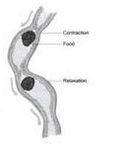
Food in the stomach
The stomach is a muscular bag where food is temporarily stored (It stays in the stomach for about 3 hours)
Food is churned by the stomach turning it into chyme
The food in the stomach which has been mixed with digestive juices is called chyme.
The stomach walls produce gastric juice
Components of gastric juice
Pepsin and rennin
Hydrochloric acid
Pepsin changes proteins to peptides
Rennin clots milk proteins
N.B Rennin is found in babies
Function of hydrochloric acid
To kill germs that escape with food to the stomach
To provide acidic PH for pepsin to digest proteins
To set unfavourable conditions for amylase
The lower end of the stomach is kept closed by a circular muscle called the pyloric sphincter which allows a little chyme at time to pass the duodenum
NB 1. Absorption of alcohol, simple sugars, common salt and medicine takes place in the stomach.
2. Chemical digestion of proteins begins in the stomach
Simple diagram to illustrate (The stomach)
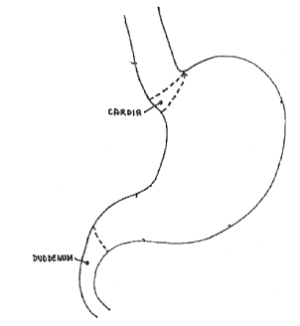
pyloric sphincter
cardiac sphincter

Food in the duodenum
- The duodenum is a U – shaped and 25cm long.
- The duodenum contains two glands
The liver and the pancreas

The liver
This produces bile juice
Bile juice is stored in the gall bladder
Bile juice is then directed to the duodenum by the bile duct
Bile juice helps to emulsify fats or break down fats for easy digestion
N.B Bile juice contains no enzyme
The pancreas produces pancreatic juice.
Pancreatic juice
This contains three enzymes
-lipase
-trypsin
-amylase
Amylase completes the digestion of carbohydrates (starch) which began in the mouth
Lipase acts on fats and turns them into fatty acids and glycerol
Trypsin acts on peptides and remaining proteins turning them into amino acids
N.B 1. No absorption of food in the body takes place in the duodenum
2. Chemical digestion of fats begins in the duodenum
Food in the ileum
Digestion of food ends in the ileum
The ileum is about 6 metres long
Absorption of food takes place in the ileum
Absorption is a process by which digested food is taken into the blood stream.
It uses the villi to absorb food nutrients
The villi are finger-like structures covering the wall of the ileum
Adaptations of the ileum to absorbing digested food
It has villi hat absorb digested food
It has thin walls for easy diffusion of digested food
It has a network of blood capillaries
It is long and coiledincreasing a surface area for food absorption
The digestive juice produced in the ileum
Succusentericus

Enzymes contained in succusentericus(Intestinal juice)

- maltase
- lactase
- sucrase
- lipase
- peptidase (erepsin)

Maltase turns maltose to glucose
Lactase turns lactose to glucose
Sucraseturns sucrose to glucose
Lipase turns lipids into fatty acids and glycerol
Peptidase (erepsin) turns peptides to amino acids
Summary
Class of foodEnd product of digestion
Proteins amino acids
Carbohydrates glucose
Fats and oils (lipids) fatty acids and glycerol
Note: The end product in the digestion of protein is amino acids, digestion of fats is fatty acids and glycerol and in the digestion of carbohydrates.

Uses of digested food by our bodies
- The maltose, glucose (from carbohydrates) fatty acids and glycerol (from fats) provide energy to the body
- Amino acids (from proteins) assist in the proper growth and repair of the body tissues.
The colon
- The function of the large intestine (colon) is to absorb water and some salts are removed from their fluid wastes are absorbed into the blood stream.
- The rest of the fluid waste and undigested solid food particles are sent to rectum.
Rectum
- The rectum stores undigested food as waste matter (faeces)
- The rectum also stores worn out cells from the digestive tract.
Anus
- Passes out faeces
N.B the process by which un digested food is passed out the body is called egestion
Importance of roughage
It prevents constipation
It stimulates peristalsis
It reduces the risk of getting bowel cancer.
Activity
- Explain the term absorption of food?
- Where does absorption of food take place?
- How is the ileum adapted to food absorption?
- Where does absorption of the following foods take place?

- Alcohol
- Water
- Digested food
- Where does digestion of fats take place in the mouth?
- Write down things that happen to food in the mouth?
- By what process does food move down the gullet?
- Identify the two enzymes produced in the stomach.
- State the major function of the following parts of digestive system.

- Gall bladder
- liver

- Name tee enzyme that breaks down carbohydrates into maltose
- What is the major role of bile produced by the liver in the digestive process?
- Identify the major function of a spleen.
- Identify the digestive juice produced by

- pancreas
- stomach

Summary table of digestive processes
Organ | Gland | Digestive juice | Enzymes | Food changes
Mouth | Salivary glands | saliva | Ptyalin or salivary amylase | Starch to maltose
Stomach | Gastric glands | Gastric juice | pepsin | Proteins to peptides
 |  |  | Rennin | clot milk in babies
Duodenum | liver | bile | No enzyme | Emulsifies the fats
 | pancreas | Pancreatic juice | Trypsin | Proteins and peptides to amino – acids
 |  |  | Amylase | Starch to maltose
 |  |  | Lipase | fats to fatty acids and glycerol
Ileum |  | Intestinal juice or succusentericus | Lactase  Maltase | Lactose to glucose  Maltose to glucose
 |  |  | Sucrase | Sucrose to glucose
 |  |  | Lipase | Fats to fatty acids and glycerol
 |  |  | peptidase | Peptides to amino - acids
colon |  |  |  | Absorption of water
Rectum |  |  |  | Storage of faeces

Digestive disorders(disturbance to alimentary canal and make it fail to function properly)
Constipation
- This is a condition where by a person finds it difficult to pass out faeces. The faeces are very hard and dry and do not come out easily
Causes
- lack of roughages in one’s diet
- having irregular meals
- drinking too little water
- lack of exercise to the body
Indigestion
- This happens when food is not properly digested
- A person feels stomach pains, heart burn (burning in the chest) and tiredness.
Causes
- No chewing food properly
- Eating so hurriedly
- Too much drinking of alcohol
Intestinal obstruction
- Caused when intestines twist or fold themselves causes vomiting, thirst and death if not reported immediately to the doctor.
Vomiting
This is the expulsion of undigested food through the mouth
- This is a sign of very many diseases.
- It disturbs the digestive system and forces the cardiac sphincter to open and the food in the stomach to be ejected through the mouth.
Diseases of the digestive system
The diseases associated with the alimentary canal include;

- Appendicitis
- Peptic ulcers
- cholera
- Typhoid
- Diarrhoea

Appendicitis
- This is the inflammation of the appendix.
- This may be due to stones or other indigestible solids that get trapped in the appendix.
- See the doctor for medical attention.

Peptic ulcers
- These are sores in the stomach wall caused by too much aid.
- The victim experiences a chronic sharp pain in the stomach and frequent heart burn.
Dysentery
- It is caused by a bacterium or Amoeba got by eating uncooked food or dirty food or water.
- The victim visits the toilet very frequently, passing out watery stool with some blood.
Typhoid
- Caused by bacteria which cause inflammation of the intestine and easily lead to death.
- It is spread through drinking contaminated water
Ways through which food is made dirty
- Handling food with dirt hands.
- House flies landing on food with their hairy bodies.
- Use of dirty containers to keep food.
- Leaving food uncovered.
- Preparing food in dirty places.
Good eating habits
- Washing hands before serving or eating food..
- Chewing food properly before swallowing.
- Avoid talking while eating food
- Washing fruits/vegetables before eating them (germs).

How to improve on the working condition of digestive system.
- Have daily physical exercises.
- Avoid eating stale or rotten food.
- Having a balanced diet.
- Avoid drinking too much alcohol..
- Have regular meals.
- Always eat the right quantity of food.
- Avoid eating while talking.
- Drink safe clean water
Activity
- Write down three diseases and three disorders of digestive system.

- diseases
- disorders

- Suggest any two ways through which food we eat gets contaminated.
- Write down at least two examples of food eating habits.
- Why should food be covered immediately after being oared?
- How are house flies adapted to spreading of diseases?

